

**National University**



of Computer

and

Emerging Sciences

Chiniot

-

Faisalabad Campus



**EE1005 – Digital Logic Design**

**Quiz# 2**

**Instructor:** Muhammad Adeel Tahir

**Sections:** BCS-2F

**Time:** 60 Minutes

**Name: _____________________________**

**Roll No: ____________________________ Total Marks: 50**

**Instructions:**

* Read each question carefully; marks will be deducted for not meeting the requirements.
* **Scientific calculators** are **not permitted** during the quiz.
* Marks for each question are indicated alongside the question.

**Question 1: Solve the following parts of the questions carefully.                         [12 marks]**

1. Convert the sequence from to Gray code. Show proper working or no marks will be given **(2+2=4)**
2. Convert the following into BCD code and add: 295 + 157                    **(2)**

1. In an 8-bit two’s-complement system, what decimal number does the bit pattern **10000111** represent? Show proper steps in finding the actual decimal number. **(2)**

1. One of the following bit patterns is valid BCD (binary-coded decimal), but the other one is not, Which one is not valid? For credit to be given, you must give a correct reason. **(1)**

1. **100110110100**
2. **100100111000**

**____________________________________________________________________________________________________________________________________________________**

What number does the valid bit pattern from part (d) represent? Give your answer in base

ten.  **(1)**

**________________________________________________________________________**

**e.** The *ten-bit* Gray code for (**353)10** is **0111010001**. Explain briefly but precisely why it cannot be true that **0111010100** is the ten-bit Gray code for (**354)10** **also** calculate gray code for 35410.

**(2)**

**Reason:____________________________________________________________________________________________________________________________________________________________________________________________________________________________________________________________________________________________________**

**Gray code for 35410: _________**

**Question 2: Solve the following problems, show proper working. [15 marks]**

1. Using 10's complement. subtract 72532 - 3250. **(2)**

1. Given the two binary numbers **X = 1010100** and **Y = 1000011** perform the subtraction

i)   X - Y and  **(2)**

ii)  Y - X by using 2's complements.**(2)**

1. Simplify the given Boolean expressions, and specify the laws used for each step within brackets where the question does not specifically mention which laws to be used. **Note**: If the laws used are not mentioned, the question will receive zero marks even if the answer is correct. **(4)**
2. Apply Demorgan’s theorem to the following expressions: **(1+1+1=3)**
3. Taking the Boolean expression of **Exclusive OR Gate as starting point**. Use any rules or laws that are applicable to **develop an expression for the exclusive-NOR gate**. **(2)**

**Working:**

**Q3: Given the following circuit below, Solve the given parts carefully. [10]**

1. Derive the Boolean expression from the following circuit diagram. Make sure you label each output carefully in neat and clean handwriting (**on the diagram)** to score the maximum marks. Write your final answer in the space provided. **(5)**
2. Draw the truth table of the derived equation. **(5)**

**F = _____________________**

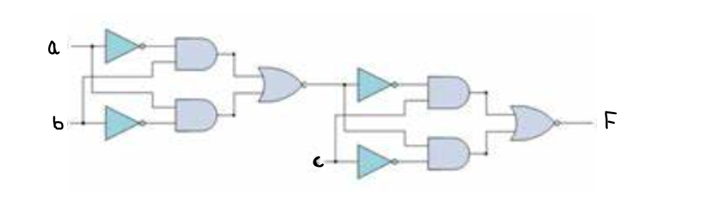

**Truth Table:**

**Q:4 Determine the output time diagram (waveform) for the XOR gate and for the XNOR gate, given the input waveforms, A and B, in Figure given below. (5)**

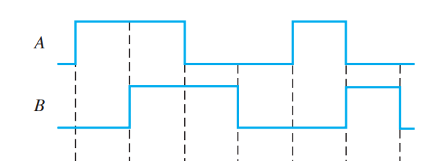

**XOR**

**XNOR**

**Q5: Convert the hexadecimal to base-7. Proper working must be shown. (2.5+2.5=5)**

**(9A3.F)16**

**Q:6 Choose the correct answer [3 marks]**

**1) Which of the following is a characteristic of Gray Code?**

a) Only one bit changes at a time

b) It is a weighted code

c) It is a decimal to binary code

d) All of the above

**2) What is the range of 8-bit signed binary numbers?**

a) -128 to 127

b) 0 to 255

c) -256 to 255

d) -127 to 128

**3) Which of the following gates is known as an inverter?**

a) AND gate

b) OR gate

c) NOT gate

d) NAND gate